COURSEWORK REPORT

Analysis and Design of a Computer Network using Cisco Packet Tracer

# Table of Contents

Introduction 4

Objectives 4

Task 2.1.0 4

Task 2.1.1 4

Task 3.0.0 4

Design 5

Task: 3.1.1 5

Task: 3.1.2 5

Task 4.1.0 6

Task 5.1.0 8

Task 5.1.1 9

Simulation 12

Router Interface Configuration 12

DHCP Configuration 12

RIP Configuration 14

Security Configuration 14

Running Configuration 15

Router0 15

Router1 16

Router2 17

Network Design 18

Results & Analysis 19

ARP 19

Task 6.0.0 20

Subnet A 20

Subnet B 20

Subnet C 21

Subnet D 21

Subnet E 22

Subnet F 23

PDU 24

PING 24

Evaluation 31

Theoretical Analysis 31

ARP Analysis 31

Evaluation of Simulation 31

RIPv2 and Auto-Summary Evaluation 31

Conclusion 31

References 33

Table of Tables

Table 1 - Overview of Subnets and the host devices 4

Table 2 - Expanded version of Table 1 with specific devices, the prefix and subnetting orders 5

Table 3 - VLSM IP address calculations for each subnet 6

Table 4 - Types of cables to be used to connect various pairs of devices on the network 6

Table 5 - Cables required for the connections related to Subnets A, B and C 6

Table 6 - Cables required for the connections related to Subnet D 6

Table 7 - Cables required for the connections related to Subnet E 7

Table 8 - Cables required for the connections related to Subnet F 7

Table 9 - IP address and RIP configurations for devices on Subnet A 8

Table 10 - IP address and RIP configurations for devices on Subnet B 8

Table 11 - IP address and RIP configurations for devices on Subnet C 8

Table 12 - IP address and RIP configurations for devices on Subnet D 9

Table 13 - IP address and RIP configurations for devices on Subnet E 10

Table 14 - IP address and RIP configurations for devices on Subnet F 11

Table 15 - Results from communication tests of devices in Subnet A 20

Table 16 - Results from communication tests of devices in Subnet B 20

Table 17 - Results from communication tests of devices in Subnet C 21

Table 18 - Results from communication tests of devices in Subnet D 22

Table 19 - Results from communication tests of devices in Subnet E 23

Table 20 - Results from communication tests of devices in Subnet F 24

# Table of Figures

[Figure 1 - Example configuration of Router0 interfaces 12](https://myoffice.accenture.com/personal/rian_leggett_accenture_com/Documents/Documents/Uni/Year%202/Data%20Communications%20and%20Networks/Coursework/Report_u1953992.docx#_Toc71555962)

[Figure 2 - Example configuration of Router0 to be used as a DHCP server 13](https://myoffice.accenture.com/personal/rian_leggett_accenture_com/Documents/Documents/Uni/Year%202/Data%20Communications%20and%20Networks/Coursework/Report_u1953992.docx#_Toc71555963)

[Figure 3 - Configuration of host devices Gateway/DNS being switched to DHCP for automatic IPv4](https://myoffice.accenture.com/personal/rian_leggett_accenture_com/Documents/Documents/Uni/Year%202/Data%20Communications%20and%20Networks/Coursework/Report_u1953992.docx#_Toc71555964) [address allocation in each subnet 13](https://myoffice.accenture.com/personal/rian_leggett_accenture_com/Documents/Documents/Uni/Year%202/Data%20Communications%20and%20Networks/Coursework/Report_u1953992.docx#_Toc71555964)

[Figure 4- Configuration of host devices Gateway/DNS being switched to DHCP for automatic IPv4](https://myoffice.accenture.com/personal/rian_leggett_accenture_com/Documents/Documents/Uni/Year%202/Data%20Communications%20and%20Networks/Coursework/Report_u1953992.docx#_Toc71555965) [address allocation in each subnet 13](https://myoffice.accenture.com/personal/rian_leggett_accenture_com/Documents/Documents/Uni/Year%202/Data%20Communications%20and%20Networks/Coursework/Report_u1953992.docx#_Toc71555965)

Figure 5 - Example configuration of RIP on Router0 14

[Figure 6- Example security configuration on Router0 14](https://myoffice.accenture.com/personal/rian_leggett_accenture_com/Documents/Documents/Uni/Year%202/Data%20Communications%20and%20Networks/Coursework/Report_u1953992.docx#_Toc71555967)

[Figure 7 - Running configuration of Router0 15](https://myoffice.accenture.com/personal/rian_leggett_accenture_com/Documents/Documents/Uni/Year%202/Data%20Communications%20and%20Networks/Coursework/Report_u1953992.docx#_Toc71555968)

[Figure 8 - Running configuration of Router1 16](https://myoffice.accenture.com/personal/rian_leggett_accenture_com/Documents/Documents/Uni/Year%202/Data%20Communications%20and%20Networks/Coursework/Report_u1953992.docx#_Toc71555969)

[Figure 9 - Running configuration of Router2 17](https://myoffice.accenture.com/personal/rian_leggett_accenture_com/Documents/Documents/Uni/Year%202/Data%20Communications%20and%20Networks/Coursework/Report_u1953992.docx#_Toc71555970)

[Figure 10 - Complete network design from Cisco Packet Tracer 18](https://myoffice.accenture.com/personal/rian_leggett_accenture_com/Documents/Documents/Uni/Year%202/Data%20Communications%20and%20Networks/Coursework/Report_u1953992.docx#_Toc71555971)

[Figure 12 - Complex PDU set up example 2 19](https://myoffice.accenture.com/personal/rian_leggett_accenture_com/Documents/Documents/Uni/Year%202/Data%20Communications%20and%20Networks/Coursework/Report_u1953992.docx#_Toc71555972)

[Figure 11 - Complex PDU set up example 1 19](https://myoffice.accenture.com/personal/rian_leggett_accenture_com/Documents/Documents/Uni/Year%202/Data%20Communications%20and%20Networks/Coursework/Report_u1953992.docx#_Toc71555973)

[Figure 13 - Complex PDU example 1 & 2 Results 19](https://myoffice.accenture.com/personal/rian_leggett_accenture_com/Documents/Documents/Uni/Year%202/Data%20Communications%20and%20Networks/Coursework/Report_u1953992.docx#_Toc71555974)

Figure 14 - First 2 packets sent between each combination of subnets with devices (D and E, E and F & D and F) 20

[Figure 15 - Extract from the PDUs created and tested from the tables above 24](https://myoffice.accenture.com/personal/rian_leggett_accenture_com/Documents/Documents/Uni/Year%202/Data%20Communications%20and%20Networks/Coursework/Report_u1953992.docx#_Toc71555976)

[Figure 16 - A selection of PINGs from PC0 on Subnet D to other devices on the same subnet and on](https://myoffice.accenture.com/personal/rian_leggett_accenture_com/Documents/Documents/Uni/Year%202/Data%20Communications%20and%20Networks/Coursework/Report_u1953992.docx#_Toc71555977) [other subnets 25](https://myoffice.accenture.com/personal/rian_leggett_accenture_com/Documents/Documents/Uni/Year%202/Data%20Communications%20and%20Networks/Coursework/Report_u1953992.docx#_Toc71555977)

[Figure 17 - A selection of PINGs from Server0 on Subnet D to other devices on the same subnet and](https://myoffice.accenture.com/personal/rian_leggett_accenture_com/Documents/Documents/Uni/Year%202/Data%20Communications%20and%20Networks/Coursework/Report_u1953992.docx#_Toc71555978) [on other subnets 26](https://myoffice.accenture.com/personal/rian_leggett_accenture_com/Documents/Documents/Uni/Year%202/Data%20Communications%20and%20Networks/Coursework/Report_u1953992.docx#_Toc71555978)

[Figure 18 - A selection of PINGs from PC4 on Subnet E to other devices on the same subnet and on](https://myoffice.accenture.com/personal/rian_leggett_accenture_com/Documents/Documents/Uni/Year%202/Data%20Communications%20and%20Networks/Coursework/Report_u1953992.docx#_Toc71555979) [other subnets 27](https://myoffice.accenture.com/personal/rian_leggett_accenture_com/Documents/Documents/Uni/Year%202/Data%20Communications%20and%20Networks/Coursework/Report_u1953992.docx#_Toc71555979)

[Figure 19 - A selection of PINGs from Server1 on Subnet E to other devices on the same subnet and](https://myoffice.accenture.com/personal/rian_leggett_accenture_com/Documents/Documents/Uni/Year%202/Data%20Communications%20and%20Networks/Coursework/Report_u1953992.docx#_Toc71555980) [on other subnets 28](https://myoffice.accenture.com/personal/rian_leggett_accenture_com/Documents/Documents/Uni/Year%202/Data%20Communications%20and%20Networks/Coursework/Report_u1953992.docx#_Toc71555980)

[Figure 20 - A selection of PINGs from PC22 on Subnet F to other devices on the same subnet and on](https://myoffice.accenture.com/personal/rian_leggett_accenture_com/Documents/Documents/Uni/Year%202/Data%20Communications%20and%20Networks/Coursework/Report_u1953992.docx#_Toc71555981) [other subnets 29](https://myoffice.accenture.com/personal/rian_leggett_accenture_com/Documents/Documents/Uni/Year%202/Data%20Communications%20and%20Networks/Coursework/Report_u1953992.docx#_Toc71555981)

[Figure 21- A selection of PINGs from Server2 on Subnet F to other devices on the same subnet and](https://myoffice.accenture.com/personal/rian_leggett_accenture_com/Documents/Documents/Uni/Year%202/Data%20Communications%20and%20Networks/Coursework/Report_u1953992.docx#_Toc71555982) [on other subnets 30](https://myoffice.accenture.com/personal/rian_leggett_accenture_com/Documents/Documents/Uni/Year%202/Data%20Communications%20and%20Networks/Coursework/Report_u1953992.docx#_Toc71555982)

# Introduction

The aim of this project is to analyse and design a computer network simulation. I will be calculating the allocated IPv4 address using my student number (1953992) and the algorithm provided in the specification. For the build and simulation of the network I will be using cisco packet tracer.

Given the task, I have decided that the most appropriate physical network topology is the star topology. All the hosts will be connected to a switch for each subnet with those switches connected to the default gateway of the corresponding subnet.

The network will make use of classless IPv4 addresses with the relevant computational techniques. This includes calculating the number of addresses allocated to each subnet, host addresses, broadcast addresses and bit masks. I will use variable-length subnet mask (VLSM) configuration for these addresses. Furthermore, Dynamic Host Configuration Protocol (DHCP) will be used to allocate IPv4 addresses to the various devices in the network.

Finally, I will also configure the routing information protocol (RIP), which is a unicast routing protocol, to allow for communication between the 6 subnets. RIP will allow every router to communicate due to the forwarding tables shared in this link-state routing process. (Student, 2021)

# Objectives

The objectives of this project that I must meet are:

* Calculation and allocation of IPv4 addresses for each subnet
* Design of the network
* Building and simulating the network
  + Allocate IP addresses
  + Configure routers
  + Configure hosts and servers, requesting IPv4s from a DHCP server
  + Testing and simulating using PING and PDU
* Network devices communicating between subnets and within the same subnet

Task 2.1.0 – Using my student number previously mentioned and the algorithm provided I have calculated my IPv4 address as: **195.39.92.0/25**

Task 2.1.1 – At the time of writing this report, the calculated address (195.39.92.0) did not fall under any private (WhatIsMyIPAddress, n.d.) or reserved (Wikipedia, n.d.) IP addresses.

### Task 3.0.0

The first table below shows the 6 subnets to be configured in this project. 3 routers will be needed to allow for communication between Subnets D,E and F.

|  |  |
| --- | --- |
| **Subnets** | **Number of Hosts** |
| Subnet A | None |
| Subnet B | None |
| Subnet C | None |
| Subnet D | 1 server and 4 computers |
| Subnet E | 1 server and 18 computers |
| Subnet F | 1 server and 20 computers |

*Table 1 - Overview of Subnets and the host devices*

# Design

## Task: 3.1.1

Table 1 from above has been expanded below to show the calculations leading up to making the decision of which order subnetting will be done, including the number of host bits reserved for the host ID for each subnet. The prefix will be calculated by subtracting the number of host bits needed from the total 32 bits contained in an IPv4 address.

|  |  |  |  |  |  |  |
| --- | --- | --- | --- | --- | --- | --- |
| **Subnets** | **Number of Hosts** | **Comments** | **Nearest**  **Decimal** | **Host Bits**  **Needed** | **Prefix** | **Subnetting**  **Order** |
| Subnet  A | None | 2 routers | 4 | 2 | 30 | 6 |
| Subnet B | None | 2 routers | 4 | 2 | 30 | 5 |
| Subnet C | None | 2 routers | 4 | 2 | 30 | 4 |
| Subnet D | 1 server and 4 computers | 6 devices including a  router | 8 | 3 | 29 | 3 |
| Subnet E | 1 server and 18 computers | 20 devices including a  router | 32 | 5 | 27 | 2 |
| Subnet F | 1 server and 20 computers | 22 devices including a  router | 32 | 5 | 27 | 1 |

*Table 2 - Expanded version of Table 1 with specific devices, the prefix and subnetting orders*

Since 2n – 2 >= number of devices in the network, where n is the number of host bits (Cox, 2020), the nearest decimal was calculated by finding the next index of 2 that would provide a number higher than the number of devices on each subnet. (e.g. the 7 devices on subnet D gave the nearest decimal as 8). Next, the number of host bits needed was calculated by finding the index of 2 needed to reach the nearest decimal. For example, 25 = 32 means that for the nearest decimal of 32, 5 host bits are required. Then as described above the table, the prefix was calculated by subtracting the number of host bits from 32 bits since this is the total number of bits in an IPv4 address. Finally, the subnetting order was determined by choosing subnets with the lowest prefix first and working up to those with the highest prefixes. This is because I need to allocate IPv4 addresses to the devices in subnets with the most devices first, ensuring that there are enough addresses for all devices. (NetworkLessons.com, n.d.)

## Task: 3.1.2

Table 3 below shows the network, first host, last host and broadcast IPv4 addresses for each subnet in the network. Using the subnetting order from Table 2 above, I will start with subnet F and the network address 195.39.92.0, I will then use the next IP (195.39.92.1) for the first host address. To calculate the last host address I will find the address 2n – 2 after the first host address. In this case, 2n – 2 represents how many addresses are allocated for network devices where n is the number of host bits needed as indicated from Table 2 above. This gives a last host address of 195.39.92.30 for subnet F. Finally, the broadcast address is calculated as the next address after the last host address (195.39.92.31). This process will be repeated for the subnets in the order designated from Table 2 above. Calculations for the Subnet Mask and Bit mask can be found below the table.

|  |  |  |  |  |  |  |
| --- | --- | --- | --- | --- | --- | --- |
| Subnet | Network  Address | Subnet Mask | First Host  Address | Last Host  Address | Broadcast | Bit  Mask |
| A | 195.39.92.80 | 255.255.255.252 | 195.39.92.81 | 195.39.92.82 | 195.39.92.83 | /30 |
| B | 195.39.92.76 | 255.255.255.252 | 195.39.92.77 | 195.39.92.78 | 195.39.92.79 | /30 |
| C | 195.39.92.72 | 255.255.255.252 | 195.39.92.73 | 195.39.92.74 | 195.39.92.75 | /30 |
| D | 195.39.92.64 | 255.255.255.248 | 195.39.92.65 | 195.39.92.70 | 195.39.92.71 | /29 |
| E | 195.39.92.32 | 255.255.255.224 | 195.39.92.33 | 195.39.92.62 | 195.39.92.63 | /27 |
| F | 195.39.92.0 | 255.255.255.224 | 195.39.92.1 | 195.39.92.30 | 195.39.92.31 | /27 |

*Table 3 - VLSM IP address calculations for each subnet*

2 host bits = 1111 1111. 1111 1111. 1111 1111. 1111 1100 = 255.255.255.252 (Subnet Mask) = /30

(Bit Mask)

3 host bits = 1111 1111. 1111 1111. 1111 1111. 1111 1000 = 255.255.255.248 (Subnet Mask) = /29

(Bit Mask)

5 host bits = 1111 1111. 1111 1111. 1111 1111. 1110 0000 = 255.255.255.224 (Subnet Mask) = /27

(Bit Mask)

## Task 4.1.0

|  |  |
| --- | --- |
| Connection | Type of cable used |
| 1. Between Routers and Switches | Copper Straight-through UTP |
| 2. Between Routers | Serial DTE |
| 3. Between Routers and Hosts (PCs) | Console (to connect to the routers Console/Aux interfaces via the terminal) and Copper Cross-over UTP  (to connect to the routers Ethernet interfaces) |
| 4. Between Routers and Switches | Copper Straight-through UTP |
| 5. Between Switches | Copper Cross-over UTP (networks communicate through  routers) |
| 6. Between Switches and Servers | Copper Straight-through UTP |

*Table 4 - Types of cables to be used to connect various pairs of devices on the network*

|  |  |  |
| --- | --- | --- |
| Subnet | Connected Devices | Type of Cable Used |
| **Subnet A** | Router0, Se0/0/0 – Router1, Se0/0/0 | Serial DTE |
| **Subnet B** | Router1, Se0/1/0 – Router2, Se0/0/0 | Serial DTE |
| **Subnet C** | Router2, Se0/1/0 – Router0, Se0/1/0 | Serial DTE |

*Table 5 - Cables required for the connections related to Subnets A, B and C*

#### Subnet D

|  |  |
| --- | --- |
| Connected Devices | Type of Cable Used |
| Host 1 (PC0) – Router0, Console | Console |
| Switch0 – Router0, Fa0/0 | Copper Straight-through UTP |
| Server (Server0) – Switch0 | Copper Straight-through UTP |
| Host 1 (PC0) – Switch0 | Copper Straight-through UTP |
| Host 2 (PC1) – Switch0 | Copper Straight-through UTP |
| Host 3 (PC2) – Switch0 | Copper Straight-through UTP |
| Host 4 (PC3) – Switch0 | Copper Straight-through UTP |

*Table 6 - Cables required for the connections related to Subnet D*

#### Subnet E

|  |  |
| --- | --- |
| Connected Devices | Type of Cable Used |

|  |  |
| --- | --- |
| Host 1 (PC4) – Router1, Console | Console |
| Switch1 – Router1, Fa0/0 | Copper Straight-through UTP |
| Server (Server1) – Switch1 | Copper Straight-through UTP |
| Host 1 (PC4) – Switch1 | Copper Straight-through UTP |
| Host 2 (PC5) – Switch1 | Copper Straight-through UTP |
| Host 3 (PC6) – Switch1 | Copper Straight-through UTP |
| Host 4 (PC7) – Switch1 | Copper Straight-through UTP |
| Host 5 (PC8) – Switch1 | Copper Straight-through UTP |
| Host 6 (PC9) – Switch1 | Copper Straight-through UTP |
| Host 7 (PC10) – Switch1 | Copper Straight-through UTP |
| Host 8 (PC11) – Switch1 | Copper Straight-through UTP |
| Host 9 (PC12) – Switch1 | Copper Straight-through UTP |
| Host 10 (PC13) – Switch1 | Copper Straight-through UTP |
| Host 11 (PC14) – Switch1 | Copper Straight-through UTP |
| Host 12 (PC15) – Switch1 | Copper Straight-through UTP |
| Host 13 (PC16) – Switch1 | Copper Straight-through UTP |
| Host 14 (PC17) – Switch1 | Copper Straight-through UTP |
| Host 15 (PC18) – Switch1 | Copper Straight-through UTP |
| Host 16 (PC19) – Switch1 | Copper Straight-through UTP |
| Host 17 (PC20) – Switch1 | Copper Straight-through UTP |
| Host 18 (PC21) – Switch1 | Copper Straight-through UTP |

*Table 7 - Cables required for the connections related to Subnet E*

#### Subnet F

|  |  |
| --- | --- |
| Connected Devices | Type of Cable Used |
| Host 1 (PC22) – Router2, Console | Console |
| Switch2 – Router2, Fa0/0 | Copper Straight-through UTP |
| Server (Server2) – Switch2 | Copper Straight-through UTP |
| Host 1 (PC22) – Switch2 | Copper Straight-through UTP |
| Host 2 (PC23) – Switch2 | Copper Straight-through UTP |
| Host 3 (PC24) – Switch2 | Copper Straight-through UTP |
| Host 4 (PC25) – Switch2 | Copper Straight-through UTP |
| Host 5 (PC26) – Switch2 | Copper Straight-through UTP |
| Host 6 (PC27) – Switch2 | Copper Straight-through UTP |
| Host 7 (PC28) – Switch2 | Copper Straight-through UTP |
| Host 8 (PC29) – Switch2 | Copper Straight-through UTP |
| Host 9 (PC30) – Switch2 | Copper Straight-through UTP |
| Host 10 (PC31) – Switch2 | Copper Straight-through UTP |
| Host 11 (PC32) – Switch2 | Copper Straight-through UTP |
| Host 12 (PC33) – Switch2 | Copper Straight-through UTP |
| Host 13 (PC34) – Switch2 | Copper Straight-through UTP |
| Host 14 (PC35) – Switch2 | Copper Straight-through UTP |
| Host 15 (PC36) – Switch2 | Copper Straight-through UTP |
| Host 16 (PC37) – Switch2 | Copper Straight-through UTP |
| Host 17 (PC38) – Switch2 | Copper Straight-through UTP |
| Host 18 (PC39) – Switch2 | Copper Straight-through UTP |
| Host 19 (PC40) – Switch2 | Copper Straight-through UTP |
| Host 20 (PC41) – Switch2 | Copper Straight-through UTP |

*Table 8 - Cables required for the connections related to Subnet F*

## Task 5.1.0

Subnet A

|  |  |
| --- | --- |
| Router (Router0, Se0/0/0) | |
| IP Address | 195.39.92.81 |
| IP Mask | 255.255.255.252 |
| Gateway Address | N/A |
| RIP | 195.39.92.0 |

|  |  |
| --- | --- |
| Router (Router1, Se0/0/0) | |
| IP Address | 195.29.92.82 |
| IP Mask | 255.255.255.252 |
| Gateway Address | N/A |
| RIP | 195.39.92.0 |

*Table 9 - IP address and RIP configurations for devices on Subnet A*

Subnet B

|  |  |
| --- | --- |
| Router (Router1, Se0/1/0) | |
| IP Address | 195.29.92.77 |
| IP Mask | 255.255.255.252 |
| Gateway Address | N/A |
| RIP | 195.39.92.0 |

|  |  |
| --- | --- |
| Router (Router2, Se0/0/0) | |
| IP Address | 195.39.92.78 |
| IP Mask | 255.255.255.252 |
| Gateway Address | N/A |
| RIP | 195.39.92.0 |

*Table 10 - IP address and RIP configurations for devices on Subnet B*

Subnet C

|  |  |
| --- | --- |
| Router (Router2, Se0/1/0) | |
| IP Address | 195.39.92.73 |
| IP Mask | 255.255.255.252 |
| Gateway Address | N/A |
| RIP | 195.39.92.0 |

|  |  |
| --- | --- |
| Router (Router0, Se0/1/0) | |
| IP Address | 195.39.92.74 |
| IP Mask | 255.255.255.252 |
| Gateway Address | N/A |
| RIP | 195.39.92.0 |

*Table 11 - IP address and RIP configurations for devices on Subnet C*

Subnet D

|  |  |
| --- | --- |
| Router (Router0, Fa0/0) | |
| IP Address | 195.39.92.65 |
| IP Mask | 255.255.255.248 |
| Gateway Address | 195.39.92.65 (This is  the gateway) |
| RIP | 195.39.92.0 |

|  |  |
| --- | --- |
| Server (Server0) | |
| IP Address | 195.39.92.70 |
| IP Mask | 255.255.255.248 |
| Gateway Address | 195.29.92.65 |

|  |  |
| --- | --- |
| Host 1 (PC0) | |
| IP Address | 195.39.92.66 |
| IP Mask | 255.255.255.248 |
| Gateway Address | 195.29.92.65 |

|  |  |
| --- | --- |
| Host 2 (PC1) | |
| IP Address | 195.39.92.67 |
| IP Mask | 255.255.255.248 |
| Gateway Address | 195.29.92.65 |

|  |  |
| --- | --- |
| Host 3 (PC2) | |
| IP Address | 195.39.92.68 |
| IP Mask | 255.255.255.248 |
| Gateway Address | 195.29.92.65 |

|  |  |
| --- | --- |
| Host 4 (PC3) | |
| IP Address | 195.39.92.69 |
| IP Mask | 255.255.255.248 |
| Gateway Address | 195.29.92.65 |

*Table 12 - IP address and RIP configurations for devices on Subnet D*

## Task 5.1.1

Subnet E

|  |  |
| --- | --- |
| Router (Router1, Fa0/0) | |
| IP Address | 195.39.92.33 |
| IP Mask | 255.255.255.224 |
| Gateway Address | 195.39.92.33 (This is  the gateway) |
| RIP | 195.39.92.0 |

|  |  |
| --- | --- |
| Server (Server1) | |
| IP Address | 195.39.92.52 |
| IP Mask | 255.255.255.224 |
| Gateway Address | 195.39.92.33 |

|  |  |
| --- | --- |
| Host 1 (PC4) | |
| IP Address | 195.39.92.34 |
| IP Mask | 255.255.255.224 |
| Gateway Address | 195.39.92.33 |

|  |  |
| --- | --- |
| Host 2 (PC5) | |
| IP Address | 195.39.92.35 |
| IP Mask | 255.255.255.224 |
| Gateway Address | 195.39.92.33 |

|  |  |
| --- | --- |
| Host 3 (PC6) | |
| IP Address | 195.39.92.36 |
| IP Mask | 255.255.255.224 |
| Gateway Address | 195.39.92.33 |

|  |  |
| --- | --- |
| Host 4 (PC7) | |
| IP Address | 195.39.92.37 |
| IP Mask | 255.255.255.224 |
| Gateway Address | 195.39.92.33 |

|  |  |
| --- | --- |
| Host 5 (PC8) | |
| IP Address | 195.39.92.38 |
| IP Mask | 255.255.255.224 |
| Gateway Address | 195.39.92.33 |

|  |  |
| --- | --- |
| Host 6 (PC9) | |
| IP Address | 195.39.92.39 |
| IP Mask | 255.255.255.224 |
| Gateway Address | 195.39.92.33 |

|  |  |
| --- | --- |
| Host 7 (PC10) | |
| IP Address | 195.39.92.40 |
| IP Mask | 255.255.255.224 |
| Gateway Address | 195.39.92.33 |

|  |  |
| --- | --- |
| Host 8 (PC11) | |
| IP Address | 195.39.92.41 |
| IP Mask | 255.255.255.224 |
| Gateway Address | 195.39.92.33 |

|  |  |
| --- | --- |
| Host 9 (PC12) | |
| IP Address | 195.39.92.42 |
| IP Mask | 255.255.255.224 |
| Gateway Address | 195.39.92.33 |

|  |  |
| --- | --- |
| Host 10 (PC13) | |
| IP Address | 195.39.92.43 |
| IP Mask | 255.255.255.224 |
| Gateway Address | 195.39.92.33 |

|  |  |
| --- | --- |
| Host 11 (PC14) | |
| IP Address | 195.39.92.44 |
| IP Mask | 255.255.255.224 |
| Gateway Address | 195.39.92.33 |

|  |  |
| --- | --- |
| Host 12 (PC15) | |
| IP Address | 195.39.92.45 |
| IP Mask | 255.255.255.224 |
| Gateway Address | 195.39.92.33 |

|  |  |
| --- | --- |
| Host 13 (PC16) | |
| IP Address | 195.39.92.46 |
| IP Mask | 255.255.255.224 |
| Gateway Address | 195.39.92.33 |

|  |  |
| --- | --- |
| Host 14 (PC17) | |
| IP Address | 195.39.92.47 |
| IP Mask | 255.255.255.224 |
| Gateway Address | 195.39.92.33 |

|  |  |
| --- | --- |
| Host 15 (PC18) | |
| IP Address | 195.39.92.48 |
| IP Mask | 255.255.255.224 |
| Gateway Address | 195.39.92.33 |

|  |  |
| --- | --- |
| Host 16 (PC19) | |
| IP Address | 195.39.92.49 |
| IP Mask | 255.255.255.224 |
| Gateway Address | 195.39.92.33 |

|  |  |
| --- | --- |
| Host 17 (PC20) | |
| IP Address | 195.39.92.50 |
| IP Mask | 255.255.255.224 |
| Gateway Address | 195.39.92.33 |

|  |  |
| --- | --- |
| Host 18 (PC21) | |
| IP Address | 195.39.92.51 |
| IP Mask | 255.255.255.224 |
| Gateway Address | 195.39.92.33 |

*Table 13 - IP address and RIP configurations for devices on Subnet E*

Subnet F

|  |  |
| --- | --- |
| Router (Router2, Fa0/0) | |
| IP Address | 195.39.92.1 |
| IP Mask | 255.255.255.224 |
| Gateway Address | 195.39.92.1 (This is  the gateway) |
| RIP | 195.39.92.0 |

|  |  |
| --- | --- |
| Server (Server2) | |
| IP Address | 195.39.92.22 |
| IP Mask | 255.255.255.224 |
| Gateway Address | 195.39.92.1 |

|  |  |
| --- | --- |
| Host 1 (PC22) | |
| IP Address | 195.39.92.2 |
| IP Mask | 255.255.255.224 |
| Gateway Address | 195.39.92.1 |

|  |  |
| --- | --- |
| Host 2 (PC23) | |
| IP Address | 195.39.92.3 |
| IP Mask | 255.255.255.224 |
| Gateway Address | 195.39.92.1 |

|  |  |
| --- | --- |
| Host 3 (PC24) | |
| IP Address | 195.39.92.4 |
| IP Mask | 255.255.255.224 |
| Gateway Address | 195.39.92.1 |

|  |  |
| --- | --- |
| Host 4 (PC25) | |
| IP Address | 195.39.92.5 |
| IP Mask | 255.255.255.224 |
| Gateway Address | 195.39.92.1 |

|  |  |
| --- | --- |
| Host 5 (PC26) | |
| IP Address | 195.39.92.6 |
| IP Mask | 255.255.255.224 |
| Gateway Address | 195.39.92.1 |

|  |  |
| --- | --- |
| Host 6 (PC27) | |
| IP Address | 195.39.92.7 |
| IP Mask | 255.255.255.224 |
| Gateway Address | 195.39.92.1 |

|  |  |
| --- | --- |
| Host 7 (PC28) | |
| IP Address | 195.39.92.8 |
| IP Mask | 255.255.255.224 |
| Gateway Address | 195.39.92.1 |

|  |  |
| --- | --- |
| Host 8 (PC29) | |
| IP Address | 195.39.92.9 |
| IP Mask | 255.255.255.224 |
| Gateway Address | 195.39.92.1 |

|  |  |
| --- | --- |
| Host 9 (PC30) | |
| IP Address | 195.39.92.10 |
| IP Mask | 255.255.255.224 |
| Gateway Address | 195.39.92.1 |

|  |  |
| --- | --- |
| Host 10 (PC31) | |
| IP Address | 195.39.92.11 |
| IP Mask | 255.255.255.224 |
| Gateway Address | 195.39.92.1 |

|  |  |
| --- | --- |
| Host 11 (PC32) | |
| IP Address | 195.39.92.12 |
| IP Mask | 255.255.255.224 |
| Gateway Address | 195.39.92.1 |

|  |  |
| --- | --- |
| Host 12 (PC33) | |
| IP Address | 195.39.92.13 |
| IP Mask | 255.255.255.224 |
| Gateway Address | 195.39.92.1 |

|  |  |
| --- | --- |
| Host 13 (PC34) | |
| IP Address | 195.39.92.14 |
| IP Mask | 255.255.255.224 |
| Gateway Address | 195.39.92.1 |

|  |  |
| --- | --- |
| Host 14 (PC35) | |
| IP Address | 195.39.92.15 |
| IP Mask | 255.255.255.224 |
| Gateway Address | 195.39.92.1 |

|  |  |
| --- | --- |
| Host 15 (PC36) | |
| IP Address | 195.39.92.16 |
| IP Mask | 255.255.255.224 |
| Gateway Address | 195.39.92.1 |

|  |  |
| --- | --- |
| Host 16 (PC37) | |
| IP Address | 195.39.92.17 |
| IP Mask | 255.255.255.224 |
| Gateway Address | 195.39.92.1 |

|  |  |
| --- | --- |
| Host 17 (PC38) | |
| IP Address | 195.39.92.18 |
| IP Mask | 255.255.255.224 |
| Gateway Address | 195.39.92.1 |

|  |  |
| --- | --- |
| Host 18 (PC39) | |
| IP Address | 195.39.92.19 |
| IP Mask | 255.255.255.224 |
| Gateway Address | 195.39.92.1 |

|  |  |
| --- | --- |
| Host 19 (PC40) | |
| IP Address | 195.39.92.20 |
| IP Mask | 255.255.255.224 |
| Gateway Address | 195.39.92.1 |

|  |  |
| --- | --- |
| Host 20 (PC41) | |
| IP Address | 195.39.92.21 |
| IP Mask | 255.255.255.224 |
| Gateway Address | 195.39.92.1 |

*Table 14 - IP address and RIP configurations for devices on Subnet F*

# Simulation

## Router Interface Configuration

To build the network I used Cisco IOS series 2811 routers. These routers use fast ethernet connections with a bandwidth of 100 Mbps. I also used WIC-1T module expansions which allowed for communication between routers via a Serial DTE cable. (PacketTracerNetwork, 2020)

To build the subnets I followed the specifications I laid out in Table 3 above. I configured both the serial and fast ethernet interfaces for each router whilst also giving them IPv4 addresses and subnet masks. An example of this configuration from Cisco Packet Tracer can be seen below for Router0:

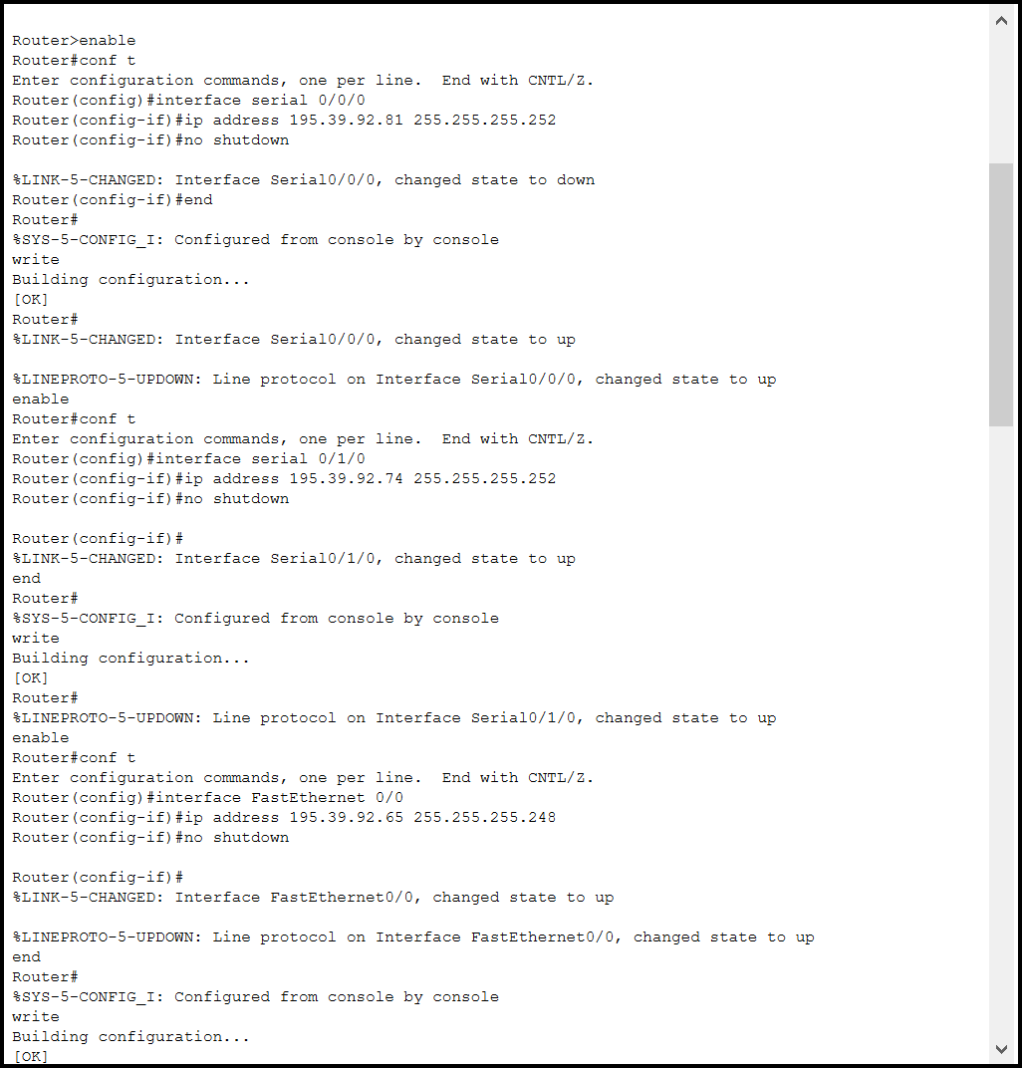

FastEthernet0/0 configuration

Serial0/1/0 configuration

Serial0/0/0 configuration

*Figure 1 - Example configuration of Router0 interfaces*

## DHCP Configuration

After completing the design of the network, the next step was to configure DHCP for IPv4 address allocation. I used each router as the default gateway, and therefore the DHCP server, for each subnet. Therefore, each router was required to respond to DHCP requests. The screenshot below is an example of configuring a DHCP pool for Router0 in Cisco Packet Tracer:

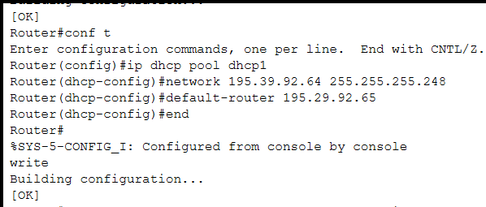

*Figure 2 - Example configuration of Router0 to be used as a DHCP server*

DHCP pool dhcp1 configuration for Subnet D in Router0 with the appropriate network ID, default gateway address and subnet mask as per VLSM calculations.

To complete DHCP configuration, I changed the Gateway/DNS IPv4 for all hosts and servers to DHCP instead of static. This allowed the IPv4 addresses to be automatically allocated in each subnet. The following screenshots show the DHCP configuration on a host (PC0) and a server (Server0) in Cisco Packet Tracer:

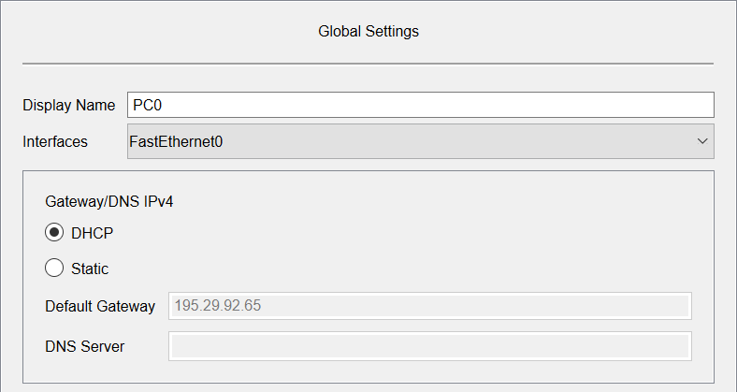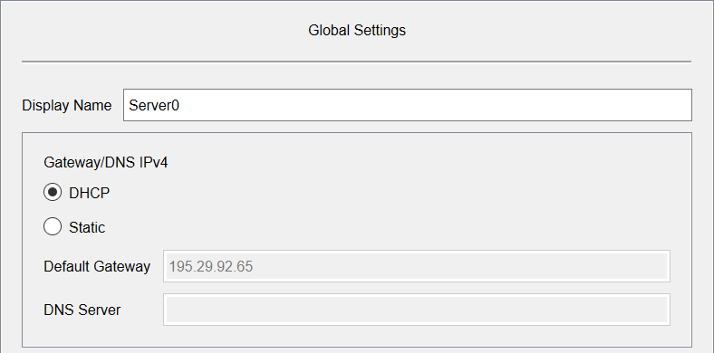

*Figure 3 - Configuration of host devices Gateway/DNS being switched to DHCP for automatic IPv4 address allocation in each subnet*

*Figure 4- Configuration of host devices Gateway/DNS being switched to DHCP for automatic IPv4 address allocation in each subnet*

DHCP Configuration option toggled.

## RIP Configuration

I used the network 195.39.92.0 for configuring the routing information protocol (RIP) in my network. This is the IPv4 address that will be defaulted to by my routers for multiple subnets in the 195.39.92.x range. Configuring RIP for my network allowed for communication between subnets.

The screenshot from Cisco Packet Tracer below shows an example of the RIPv2 (with no auto summary) configuration on Router0:

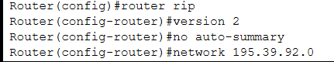

## Security Configuration

*Figure 5 - Example configuration of RIP on Router0*

Task 5.2.0 – For all 3 of my routers I set up passwords for secure access to the router via EXEC Mode (Enable), Telnet, Aux Port and Console Port. I have used the password *networks* for my network simulation. A screenshot of the configuration for Router1 in Cisco Packet Tracer can be seen below:

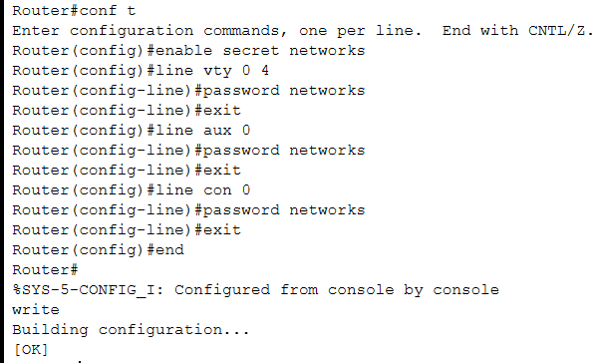

Console Port Configuration

Aux Port Configuration

Telnet Configuration

EXEC Mode (Enable) Configuration

*Figure 6- Example security configuration on Router0*

## Running Configuration

A summary of the configuration for each router can be found below under their respective heading.

### Router0

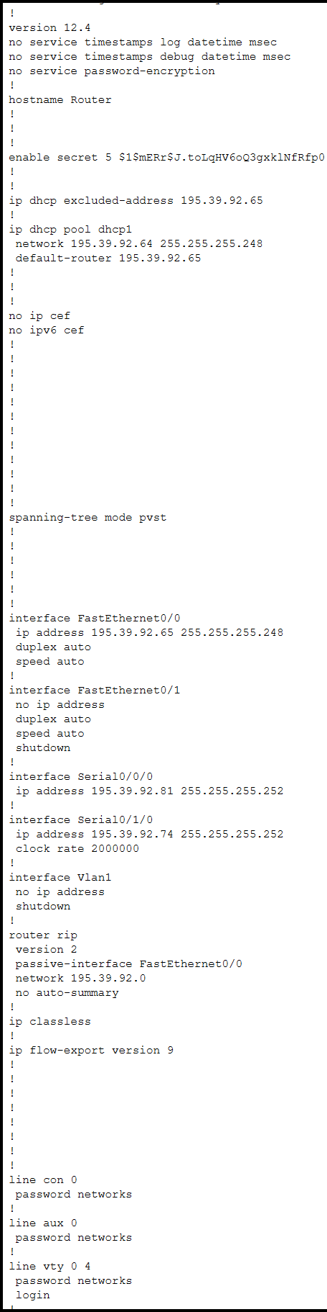

*Figure 7 - Running configuration of Router0*

### Router1

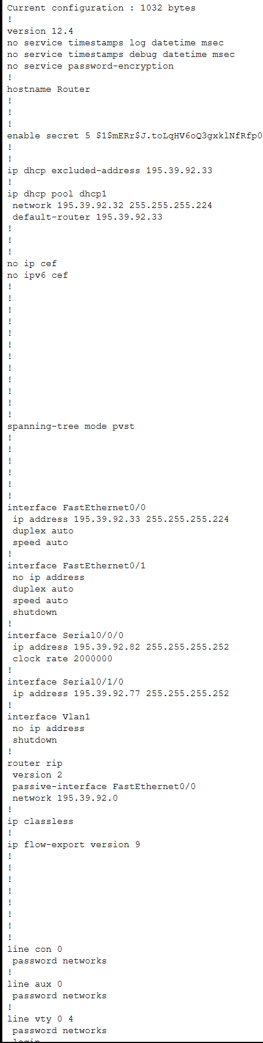

*Figure 8 - Running configuration of Router1*

### Router2

*Figure 9 - Running configuration of Router2*

### Network Design

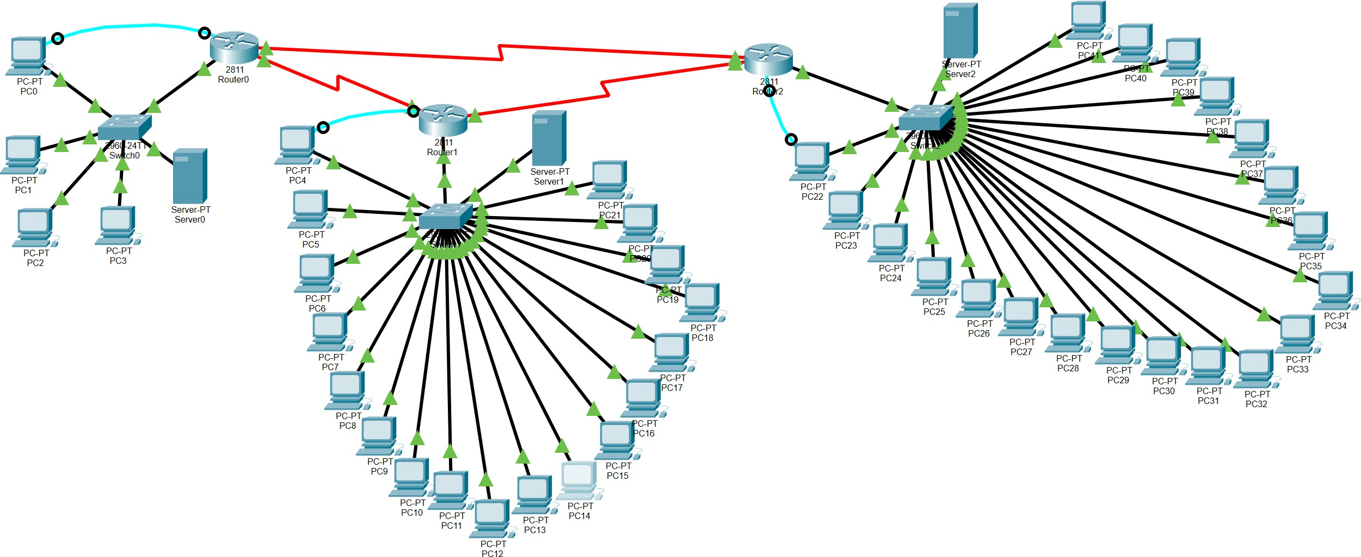

*Figure 10 - Complete network design from Cisco Packet Tracer*

# Results & Analysis

Now I have built my network, it is important that it is tested to ensure successful connections so data can be communicated across the network. To test these communications, I have used complex PDU where it was required that the destination port is specified. For all communications where the destination port was not required to be specified, I used simple PDU. The screenshot below to the left shows the creation of a complex PDU to test the connection between Router0 Se0/0/0 to Router0 Fa0/0 and the screenshot to the right shows the same for Router0 Se0/0/0 to Router1 Se0/0/0:

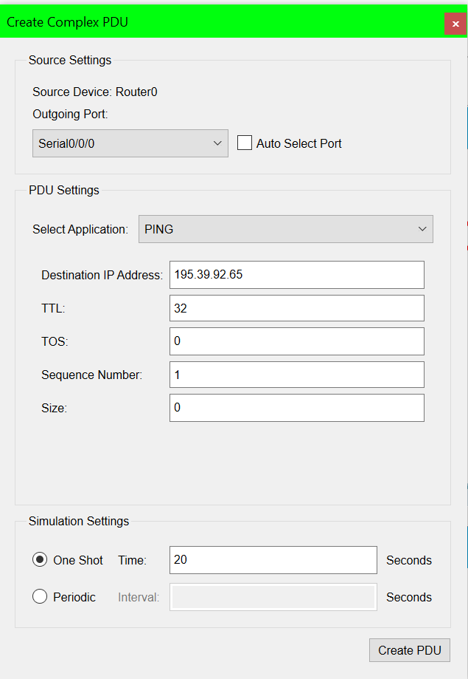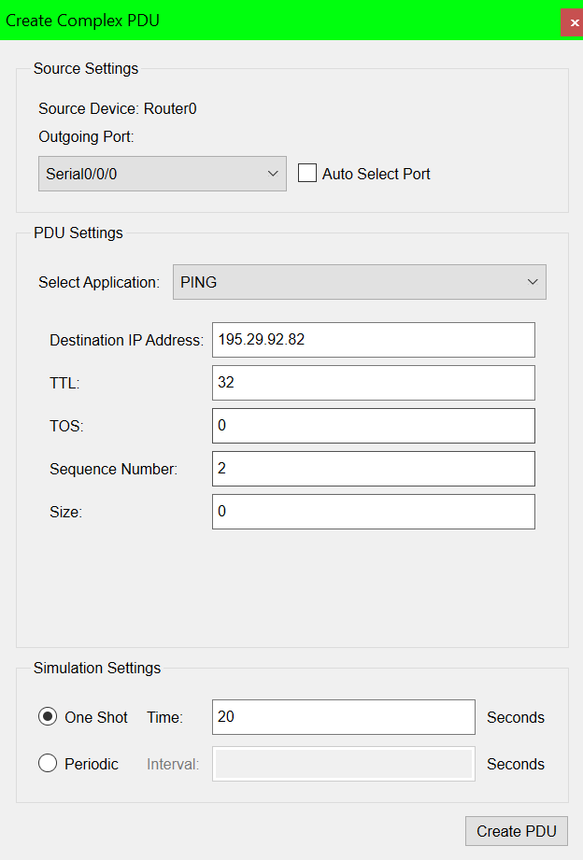

*Figure 12 - Complex PDU set up example 1 Figure 11 - Complex PDU set up example 2*

As can be seen in the screenshot below both complex PDUs were successful:

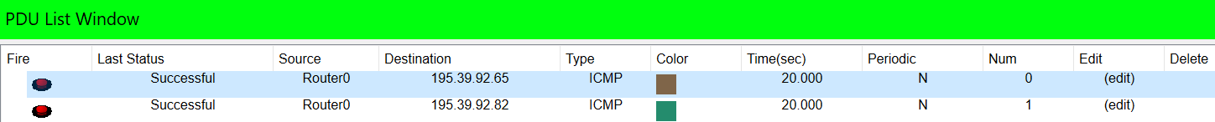

*Figure 13 - Complex PDU example 1 & 2 Results*

## ARP

The Address Resolution Protocol (ARP) tables of each router were empty when completing the first tests of communications in the network. This caused the first 3 PDUs listed below to fail. After refiring these PDUs they were successful, as can be seen by the last 3 PDUs below. This is because the ARP tables were populated following the initial 3 PDU requests resulting in successful requests. The requests attempted to communicate between subnets D & E, D & F and E & F respectively:

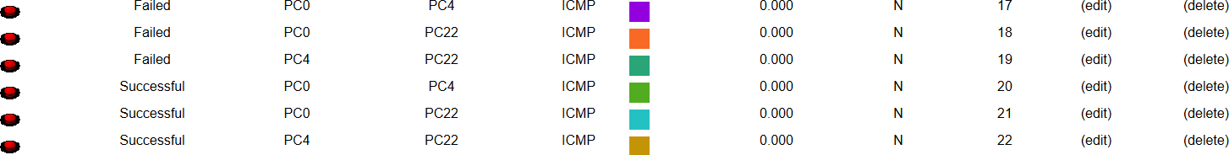

*Figure 14 - First 2 packets sent between each combination of subnets with devices (D and E, E and F & D and F)*

## Task 6.0.0

The tables below display the test results for the most important communications for each subnet. Communications on the same subnet and to all other subnets have been tested via PING and PDU requests as detailed in these tables.

### Subnet A

|  |  |  |  |  |
| --- | --- | --- | --- | --- |
| From | To | IP Address (Destination) | Subnet (Destination) | Results (S/F) |
| Router0, Se0/0/0 | Router0, Fa0/0 | 195.39.92.65 | D | S |
| Router1, Se0/0/0 | 195.39.92.82 | A (Same subnet) | S |
| Router1, Se0/1/0 | 195.39.92.77 | B | S |
| Router1, Fa0/0 | 195.39.92.33 | E | S |
| Router2, Se0/0/0 | 195.39.92.78 | C | S |
| Router2, Se0/1/0 | 195.39.92.73 | B | S |
| Router2, Fa0/0 | 195.39.92.1 | F | S |
| Router1, Se0/0/0 | Router0, Se0/0/0 | 195.39.92.81 | A (Same subnet) | S |
| Router0, Se0/1/0 | 195.39.92.74 | C | S |
| Router0, Fa0/0 | 195.39.92.65 | D | S |
| Router1, Fa0/0 | 195.39.92.33 | E | S |
| Router2, Se0/0/0 | 195.39.92.78 | C | S |
| Router2, Se0/1/0 | 195.39.92.73 | B | S |
| Router2, Fa0/0 | 195.39.92.1 | F | S |

*Table 15 - Results from communication tests of devices in Subnet A*

### Subnet B

|  |  |  |  |  |
| --- | --- | --- | --- | --- |
| From | To | IP Address (Destination) | Subnet (Destination) | Results (S/F) |
| Router1, Se0/1/0 | Router0, Se0/0/0 | 195.39.92.81 | A | S |
| Router0, Se0/1/0 | 195.39.92.74 | C | S |
| Router0, Fa0/0 | 195.39.92.65 | D | S |
| Router1, Fa0/0 | 195.39.92.33 | E | S |
| Router2, Se0/0/0 | 195.39.92.78 | C | S |
| Router2, Se0/1/0 | 195.39.92.73 | B (Same subnet) | S |
| Router2, Fa0/0 | 195.39.92.1 | F | S |
| Router2, Se0/0/0 | Router0, Se0/0/0 | 195.39.92.81 | A | S |
| Router0, Se0/1/0 | 195.39.92.74 | C | S |
| Router0, Fa0/0 | 195.39.92.65 | D | S |
| Router1, Se0/0/0 | 195.39.92.82 | A | S |
| Router1, Se0/1/0 | 195.39.92.77 | B (Same subnet) | S |
| Router1, Fa0/0 | 195.39.92.33 | E | S |
| Router2, Fa0/0 | 195.39.92.1 | F | S |

*Table 16 - Results from communication tests of devices in Subnet B*

### Subnet C

|  |  |  |  |  |
| --- | --- | --- | --- | --- |
| From | To | IP Address (Destination) | Subnet (Destination) | Results (S/F) |
| Router0, Se0/1/0 | Router0, Fa0/0 | 195.39.92.65 | D | S |
| Router1, Se0/0/0 | 195.39.92.82 | A | S |
| Router1, Se0/1/0 | 195.39.92.77 | B | S |
| Router1, Fa0/0 | 195.39.92.33 | E | S |
| Router2, Se0/0/0 | 195.39.92.78 | C (Same subnet) | S |
| Router2, Se0/1/0 | 195.39.92.73 | B | S |
| Router2, Fa0/0 | 195.39.92.1 | F | S |
| Router2, Se0/1/0 | Router0, Se0/0/0 | 195.39.92.81 | A | S |
| Router0, Se0/1/0 | 195.39.92.74 | C (Same subnet) | S |
| Router0, Fa0/0 | 195.39.92.65 | D | S |
| Router1, Se0/0/0 | 195.39.92.82 | A | S |
| Router1, Se0/1/0 | 195.39.92.77 | B | S |
| Router1, Fa0/0 | 195.39.92.33 | E | S |
| Router2, Fa0/0 | 195.39.92.1 | F | S |

*Table 17 - Results from communication tests of devices in Subnet C*

### Subnet D

|  |  |  |  |  |
| --- | --- | --- | --- | --- |
| From | To | IP Address  (Destination) | Subnet (Destination) | Results (S/F) |
| Host 1 (PC0) | Gateway (Router0, Fa0/0) | 195.39.92.65 | D (Same subnet) | S |
| Router1, Fa0/0 | 195.39.92.33 | E | S |
| Router2, Fa0/0 | 195.39.92.1 | F | S |
| Router0, Se0/0/0 | 195.39.92.81 | A | S |
| Router0, Se0/1/0 | 195.39.92.74 | C | S |
| Host 2 (PC1) | 195.39.92.66 | D (Same subnet) | S |
| Host 3 (PC2) | 195.39.92.70 | D (Same subnet) | S |
| Host 4 (PC3) | 195.39.92.67 | D (Same subnet) | S |
| Server (Server0) | 195.39.92.68 | D (Same subnet) | S |
| Subnet E – Host 1 (PC4) | 195.39.92.51 | E | F, S |
| Subnet F – Host 1 (PC22) | 195.39.92.16 | F | F, S |
| Host 2 (PC1) | Gateway (Router0, Fa0/0) | 195.39.92.65 | D (Same subnet) | S |
| Router1, Fa0/0 | 195.39.92.33 | E | S |
| Router2, Fa0/0 | 195.39.92.1 | F | S |
| Router0, Se0/0/0 | 195.39.92.81 | A | S |
| Router0, Se0/1/0 | 195.39.92.74 | C | S |
| Host 1 (PC0) | 195.39.92.69 | D (Same subnet) | S |
| Server (Server0) | 195.39.92.68 | D (Same subnet) | S |
| Host 3 (PC2) | Gateway (Router0, Fa0/0) | 195.39.92.65 | D (Same subnet) | S |
| Router1, Fa0/0 | 195.39.92.33 | E | S |
| Router2, Fa0/0 | 195.39.92.1 | F | S |
| Router1, Se0/0/0 | 195.39.92.81 | A | S |
| Router1, Se0/1/0 | 195.39.92.74 | B | S |
| Host 1 (PC0) | 195.39.92.69 | D (Same subnet) | S |
| Host 4 (PC3) | Gateway (Router0, Fa0/0) | 195.39.92.65 | D (Same subnet) | S |
| Router1, Fa0/0 | 195.39.92.33 | E | S |
| Router2, Fa0/0 | 195.39.92.1 | F | S |
| Router1, Se0/0/0 | 195.39.92.81 | A | S |
| Router1, Se0/1/0 | 195.39.92.74 | B | S |

|  |  |  |  |  |
| --- | --- | --- | --- | --- |
|  | Host 2 (PC1) | 195.39.92.66 | D (Same subnet) | S |
| Server (Server0) | Gateway (Router0, Fa0/0) | 195.39.92.65 | D (Same subnet) | S |
| Router1, Fa0/0 | 195.39.92.33 | E | S |
| Router2, Fa0/0 | 195.39.92.1 | F | S |
| Router0, Se0/0/0 | 195.39.92.81 | A | S |
| Router0, Se0/1/0 | 195.39.92.74 | C | S |
| Router1, Se0/0/0 | 195.39.92.81 | A | S |
| Router1, Se0/1/0 | 195.39.92.74 | B | S |
| Router2, Se0/0/0 | 195.39.92.78 | C | S |
| Router2, Se0/1/0 | 195.39.92.73 | B | S |
| Host 2 (PC1) | 195.39.92.66 | D (Same subnet) | S |

*Table 18 - Results from communication tests of devices in Subnet D*

### Subnet E

|  |  |  |  |  |
| --- | --- | --- | --- | --- |
| From | To | IP Address  (Destination) | Subnet (Destination) | Results (S/F) |
| Host 1 (PC4) | Router0, Fa0/0 | 195.39.92.65 | D | S |
| Gateway (Router1, Fa0/0) | 195.39.92.33 | E (Same subnet) | S |
| Router2, Fa0/0 | 195.39.92.1 | F | S |
| Router0, Se0/0/0 | 195.39.92.81 | A | S |
| Router0, Se0/1/0 | 195.39.92.74 | C | S |
| Host 2 (PC5) | 195.39.92.35 | E (Same subnet) | S |
| Host 3 (PC6) | 195.39.92.47 | E (Same subnet) | S |
| Host 4 (PC7) | 195.39.92.50 | E (Same subnet) | S |
| Server (Server1) | 195.39.92.49 | E (Same subnet) | S |
| Subnet D – Host 1 (PC0) | 195.39.92.69 | D | S |
| Subnet F – Host 1 (PC22) | 195.39.92.16 | F | F, S |
| Host 2 (PC5) | Router0, Fa0/0 | 195.39.92.65 | D | S |
| Gateway (Router1, Fa0/0) | 195.39.92.33 | E (Same subnet) | S |
| Router2, Fa0/0 | 195.39.92.1 | F | S |
| Router0, Se0/0/0 | 195.39.92.81 | A | S |
| Router0, Se0/1/0 | 195.39.92.74 | C | S |
| Host 1 (PC4) | 195.39.92.51 | E (Same subnet) | S |
| Server (Server1) | 195.39.92.49 | E (Same subnet) | S |
| Host 3 (PC6) | Router0, Fa0/0 | 195.39.92.65 | D | S |
| Gateway (Router1, Fa0/0) | 195.39.92.33 | E (Same subnet) | S |
| Router2, Fa0/0 | 195.39.92.1 | F | S |
| Router1, Se0/0/0 | 195.39.92.81 | A | S |
| Router1, Se0/1/0 | 195.39.92.74 | B | S |
| Host 1 (PC4) | 195.39.92.51 | E (Same subnet) | S |
| Host 4 (PC7) | Router0, Fa0/0 | 195.39.92.65 | D | S |
| Gateway (Router1, Fa0/0) | 195.39.92.33 | E (Same subnet) | S |
| Router2, Fa0/0 | 195.39.92.1 | F | S |
| Router1, Se0/0/0 | 195.39.92.81 | A | S |
| Router1, Se0/1/0 | 195.39.92.74 | B | S |
| Host 2 (PC5) | 195.39.92.35 | E (Same subnet) | S |
| Server (Server1) | Router0, Fa0/0 | 195.39.92.65 | D | S |
| Gateway (Router1, Fa0/0) | 195.39.92.33 | E (Same subnet) | S |
| Router2, Fa0/0 | 195.39.92.1 | F | S |
| Router0, Se0/0/0 | 195.39.92.81 | A | S |

|  |  |  |  |  |
| --- | --- | --- | --- | --- |
|  | Router0, Se0/1/0 | 195.39.92.74 | C | S |
| Router1, Se0/0/0 | 195.39.92.81 | A | S |
| Router1, Se0/1/0 | 195.39.92.74 | B | S |
| Router2, Se0/0/0 | 195.39.92.78 | C | S |
| Router2, Se0/1/0 | 195.39.92.73 | B | S |
| Host 2 (PC5) | 195.39.92.35 | E (Same subnet) | S |

*Table 19 - Results from communication tests of devices in Subnet E*

### Subnet F

|  |  |  |  |  |
| --- | --- | --- | --- | --- |
| From | To | IP Address  (Destination) | Subnet (Destination) | Results (S/F) |
| Host 1 (PC22) | Router0, Fa0/0 | 195.39.92.65 | D | S |
| Router1, Fa0/0 | 195.39.92.33 | E | S |
| Gateway (Router2, Fa0/0) | 195.39.92.1 | F (Same subnet) | S |
| Router0, Se0/0/0 | 195.39.92.81 | A | S |
| Router0, Se0/1/0 | 195.39.92.74 | C | S |
| Host 2 (PC23) | 195.39.92.19 | F (Same subnet) | S |
| Host 3 (PC24) | 195.39.92.20 | F (Same subnet) | S |
| Host 4 (PC25) | 195.39.92.5 | F (Same subnet) | S |
| Server (Server2) | 195.39.92.9 | F (Same subnet) | S |
| Subnet D – Host 1 (PC0) | 195.39.92.69 | D | S |
| Subnet E – Host 1 (PC4) | 195.39.92.51 | E | S |
| Host 2 (PC23) | Router0, Fa0/0 | 195.39.92.65 | D | S |
| Router1, Fa0/0 | 195.39.92.33 | E | S |
| Gateway (Router2, Fa0/0) | 195.39.92.1 | F (Same subnet) | S |
| Router0, Se0/0/0 | 195.39.92.81 | A | S |
| Router0, Se0/1/0 | 195.39.92.74 | C | S |
| Host 1 (PC22) | 195.39.92.16 | F (Same subnet) | S |
| Server (Server2) | 195.39.92.9 | F (Same subnet) | S |
| Host 3 (PC24) | Router0, Fa0/0 | 195.39.92.65 | D | S |
| Router1, Fa0/0 | 195.39.92.33 | E | S |
| Gateway (Router2, Fa0/0) | 195.39.92.1 | F (Same subnet) | S |
| Router1, Se0/0/0 | 195.39.92.81 | A | S |
| Router1, Se0/1/0 | 195.39.92.74 | B | S |
| Host 1 (PC22) | 195.39.92.16 | F (Same subnet) | S |
| Host 4 (PC25) | Router0, Fa0/0 | 195.39.92.65 | D | S |
| Router1, Fa0/0 | 195.39.92.33 | E | S |
| Gateway (Router2, Fa0/0) | 195.39.92.1 | F (Same subnet) | S |
| Router1, Se0/0/0 | 195.39.92.81 | A | S |
| Router1, Se0/1/0 | 195.39.92.74 | B | S |
| Host 2 (PC23) | 195.39.92.19 | F (Same subnet) | S |
| Server (Server2) | Router0, Fa0/0 | 195.39.92.65 | D | S |
| Router1, Fa0/0 | 195.39.92.33 | E | S |
| Gateway (Router2, Fa0/0) | 195.39.92.1 | F (Same subnet) | S |
| Router0, Se0/0/0 | 195.39.92.81 | A | S |
| Router0, Se0/1/0 | 195.39.92.74 | C | S |
| Router1, Se0/0/0 | 195.39.92.81 | A | S |
| Router1, Se0/1/0 | 195.39.92.74 | B | S |
| Router2, Se0/0/0 | 195.39.92.78 | C | S |
| Router2, Se0/1/0 | 195.39.92.73 | B | S |

|  |  |  |  |  |
| --- | --- | --- | --- | --- |
|  | Host 2 (PC23) | 195.39.92.19 | F (Same subnet) | S |

*Table 20 - Results from communication tests of devices in Subnet F*

### PDU

The screenshot displayed below shows a selection of the PDU requests detailed in the tables above.

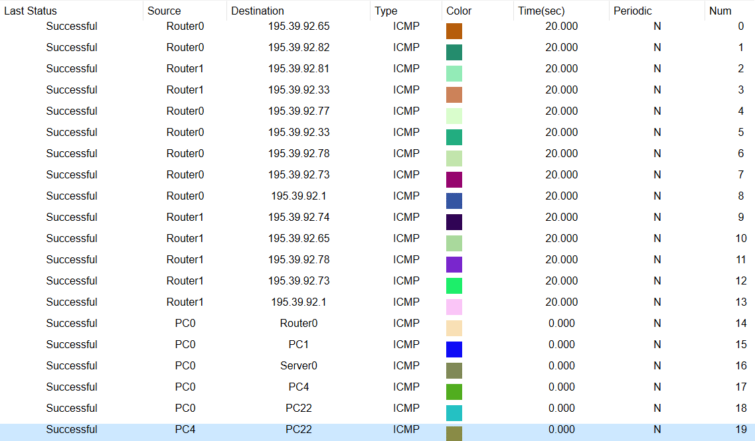

*Figure 15 - Extract from the PDUs created and tested from the tables above*

### PING

PING requests were also made by relevant hosts and servers to test connectivity between network devices on subnets D, E and F. The following screenshots, organised by which subnet the source device belongs to, show the source device in the top left corner and the ping commands used to connect this device to other devices. These are some examples of the connections between hosts/servers and other hosts/servers detailed in Tables 15-20 above.

Subnet D

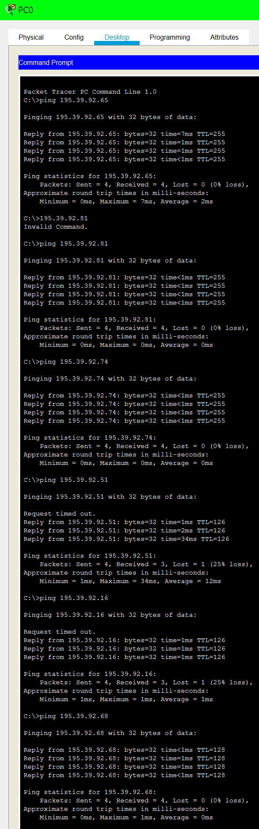

*Figure 16 - A selection of PINGs from PC0 on Subnet D to other devices on the same subnet and on other subnets*

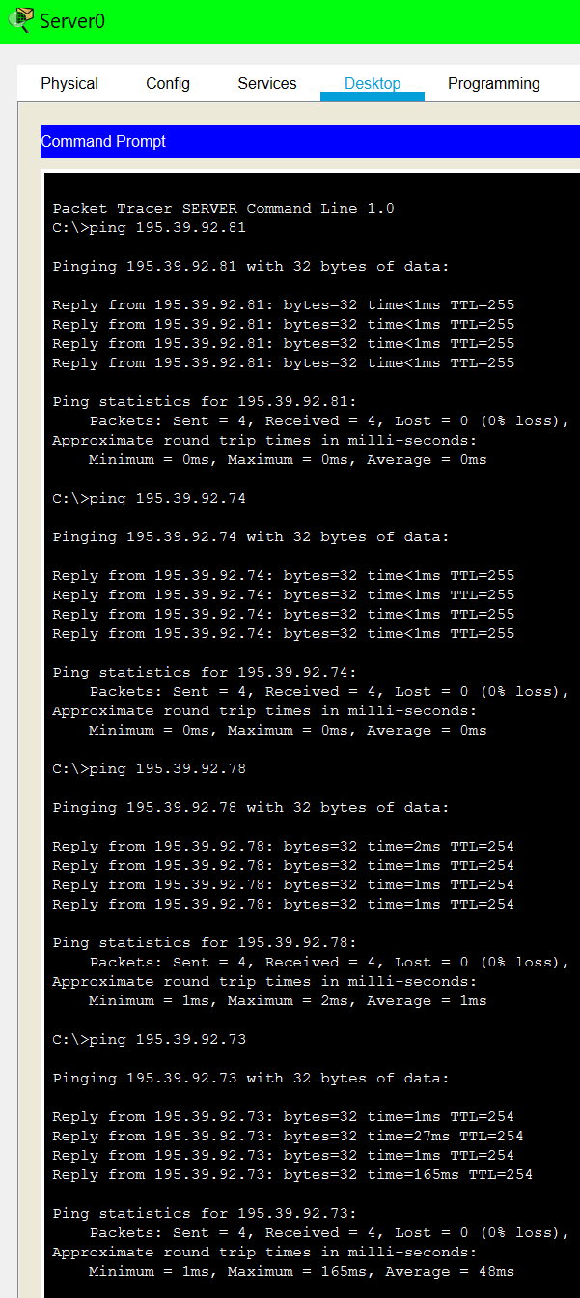

*Figure 17 - A selection of PINGs from Server0 on Subnet D to other devices on the same subnet and on other subnets*

Subnet E

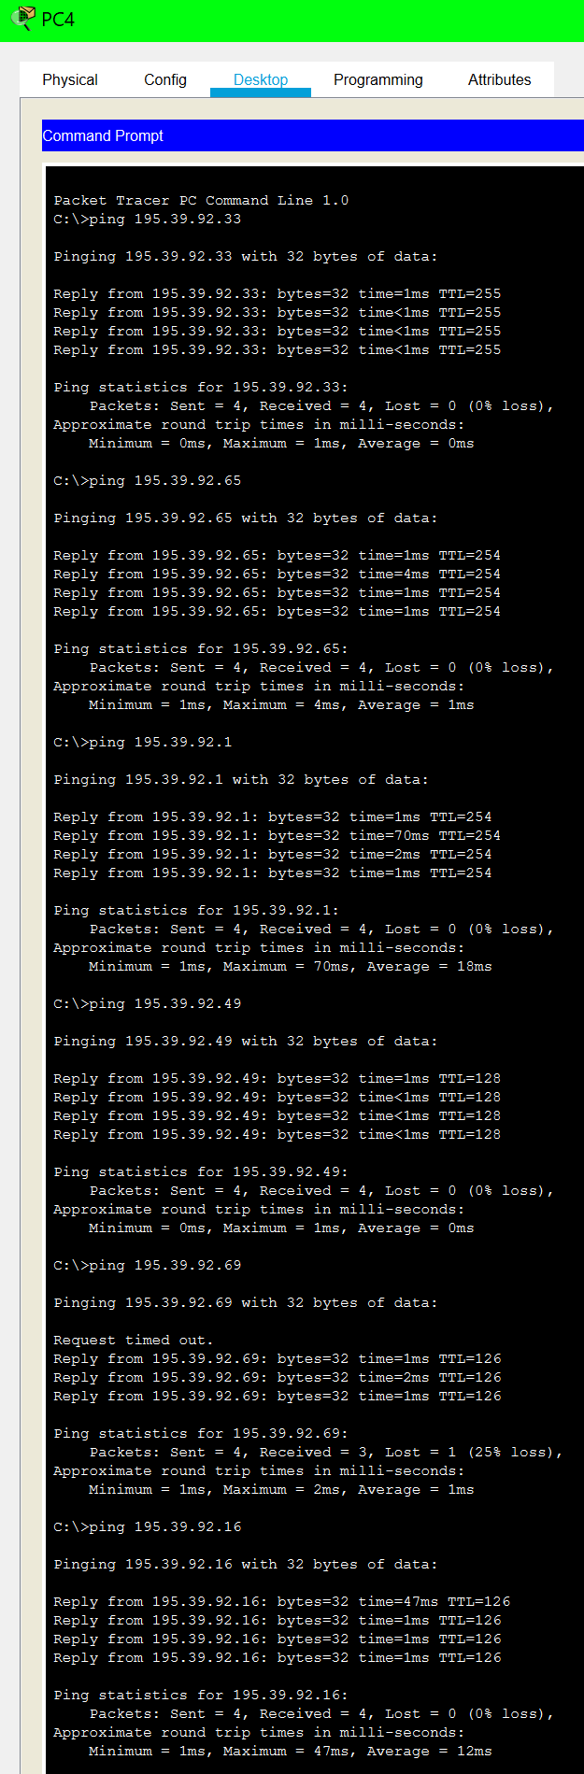

*Figure 18 - A selection of PINGs from PC4 on Subnet E to other devices on the same subnet and on other subnets*

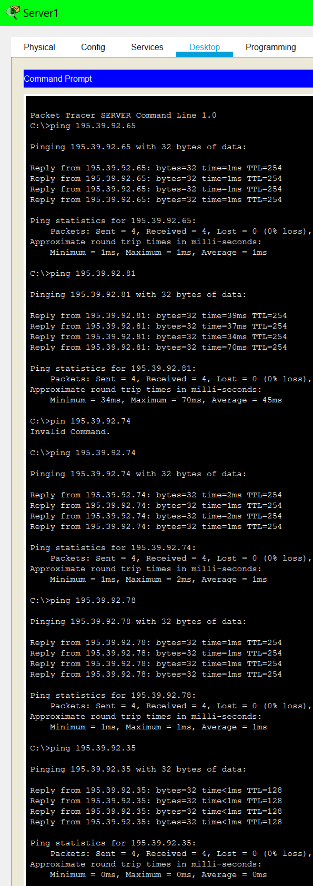

*Figure 19 - A selection of PINGs from Server1 on Subnet E to other devices on the same subnet and on other subnets*

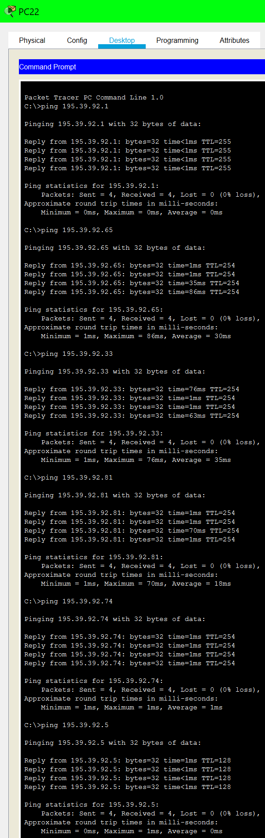Subnet F

*Figure 20 - A selection of PINGs from PC22 on Subnet F to other devices on the same subnet and on other subnets*

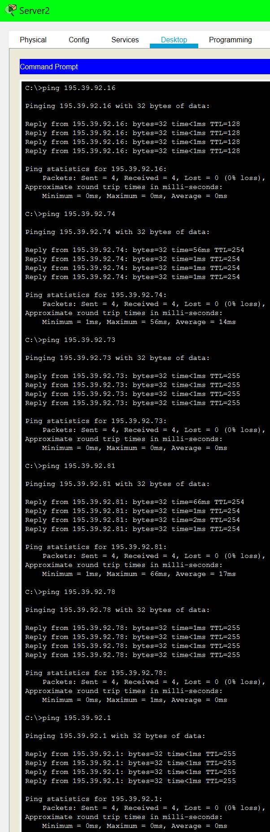

*Figure 21- A selection of PINGs from Server2 on Subnet F to other devices on the same subnet and on other subnets*

# Evaluation

## Theoretical Analysis

The testing results from Tables 15-20 above demonstrate the successful configuration of the network. These successes also indicate that the IPv4 address and VLSM calculations from Tables 1, 2 and 3 were correct for this network. Furthermore, the successful communications between devices on different subnets shows that RIP was successfully configured in my network. The initial failures for 3 of the communications being tested resulted due to the Address Resolution Protocol (ARP) tables of each router being empty. After the first run of these PDUs the ARP tables were populated allowing for the packets being communicated across different subnets to be routed to the appropriate destination, resulting in successful communications thereafter. More depth on these ARP tables can be found in the analysis below. (Student, 2021)

## ARP Analysis

In my network simulation, the first packets sent from a host device in one subnet to a host device on another subnet failed to be communicated. This was the case because the ARP tables for the routers were empty on boot. After these first three PDUs failed, refiring the PDUs allowed them to be successfully communicated. The successes after the initial failures occur because the ARP tables of the routers have now been populated, which gave the routers information on the source and destination network devices as well as the number of hops for the next device.

This can also be seen in the screenshots of the PING tests above where the first request of a packet being sent fails between host devices on different subnets, but the following 3 packets succeed.

## Evaluation of Simulation

The objectives of the network simulation have all been met. I calculated and allocated the IPv4 addresses for each subnet as well as designing and building the network. I used cisco packet tracer to configure routers, configure hosts/servers using the routers as DHCP servers to automatically allocate IP addresses and simulate the network by testing PING and PDU commands. The simulation also allowed me to meet my objective of devices communicating on the same subnet and between different subnets, since these communication tests were successful.

I was able to meet all my requirements with DHCP and RIPv2 configuration. I also added security to my network so that configurations are secure and would be less susceptible to cyber security attacks if the network designed was implemented.

## RIPv2 and Auto-Summary Evaluation

I was required to use RIPv2 instead of RIPv1 because version 2 is classless and fully supports VLSM, allowing varying subnet masks to exist in my network. Whereas, version 1 is classful and only supports FLSM which would not allow the varying subnet masks required for my network.

I was also required to ensure the RIP used had auto-summary disabled. This was achieved through the use of the ‘no auto-summary’ command when configuring the router RIP. Auto-summary being disabled allowed for the classless IP addresses used in my network, since auto-summary would summarise the IP addresses as a classful network. (Cisco, n.d.)

# Conclusion

In summary, the network designed was made up of 51 devices in total. These devices include 42 host PCs, 3 servers, 3 switches and 3 routers. The necessary cables, as defined in Table 4, were used to connect each device in the network and form the 6 subnets required. 3 of these subnets (A, B and C)

consisted of router pairs with no host devices whereas the other 3 subnets (D, E and F) consisted of a router, switch, server and a number of PC devices.

Routers were configured as DHCP servers to automatically allocate the host PC and server IPv4 addresses in each subnet. Each router was also configured as a gateway for the network and to use RIPv2 with no auto-summary in order to allow for communications across different subnets.

All 6 subnets were configured as per the VLSM calculations carried out in Tables 2 and 3. In the simulation, communications between various network devices and ports was tested. This allowed for the objectives set out at the start of the project to be proven successful as discussed in the evaluation above. As per the simulation results, the network devices were able to successfully communicate both within the same subnet and across different subnets.

# References

Cisco, n.d. *Cisco IOS IP Routing: RIP Command Reference.* [Online] Available at:

https://[www.cisco.com/c/en/us/td/docs/ios/iproute_rip/command/reference/irr_book/irr_rip.html](http://www.cisco.com/c/en/us/td/docs/ios/iproute_rip/command/reference/irr_book/irr_rip.html) [Accessed 19 April 2021].

Cox, J., 2020. *Introduction to Subnetting – How to Calculate Subnets, CIDR, VLSM and More!.* [Online]

Available at: https://[www.ittsystems.com/introduction-to-subnetting/](http://www.ittsystems.com/introduction-to-subnetting/) [Accessed 12 April 2021].

Forouzan, B. A., 2013. *Data Communications and Networking.* 5th ed. New York: McGraw-Hill. NetworkLessons.com, n.d. *Variable Length Subnet Mask (VLSM).* [Online]

Available at: https://networklessons.com/subnetting/variable-length-subnet-mask-vlsm [Accessed 12 April 2021].

PacketTracerNetwork, 2020. *Packet Tracer 7.3.1 - Router devices and WIC modules.* [Online] Available at: https://[www.packettracernetwork.com/features/cisco-wic-modules.html](http://www.packettracernetwork.com/features/cisco-wic-modules.html) [Accessed 10 April 2021].

Student, P., 2021. *CD5002 - Sample Coursework Report.* [Online] Available at:

https://moodle.uel.ac.uk/pluginfile.php/2534983/mod_resource/content/2/Sample%20Coursework

%20Report.pdf [Accessed April 2021].

WhatIsMyIPAddress, n.d. *Did you know you have a private IP address?.* [Online]

Available at: https://whatismyipaddress.com/private-ip [Accessed 17 March 2021].

Wikipedia, n.d. *Reserved IP addresses.* [Online]

Available at: https://en.wikipedia.org/wiki/Reserved_IP_addresses [Accessed 17 March 2021].